WEB TECHNOLOGIES LAB MANUAL

**Submitted to :** Pf. Kiran Jyoti

**Submitted by :** Swapleen Kaur Arora

**C.R.N :** 1921105 **U.R.N :** 1905405

**PRACTICAL NO. 1**

Create a simple web pages by writing HTML using a simple text editor, notepad. Demonstrate the following components of the web page : page title and headings paragraph and inline images.

<!DOCTYPE html>

<html>

<html lang='eng'>

<head>

<title>WT Practical 1</title>

</head>

<h1 style="color:red"><center><strong><em>GURU NANAK DEV ENGINEERING COLLEGE</em></strong></center></h1>

<h2 style="color:blue"><center><b><i>Gill Road Gill Park, Ludhiana.</i></b></center></h2>

<body>

<img src="https://www.gndec.ac.in/sites/default/logo.png" alt="gne" width="1500" height="150">

<p style="color:black; font-family = Bell MT"><b>Guru Nanak Dev Engineering College</b>, one of the prestigious, oldest and minority institution of Northern India, was established under the aegis of Nankana Sahib Education Trust (NSET) in 1956. NSET was founded in memory of the most sacred temple of Nankana Sahib, birth place of Guru Nanak Dev Ji. Shiromani Gurudwara Prabandhak Committee, Amritsar, a premier organization of universal brotherhood, which is the main force behind the mission of "Removal of Economic Backwardness through Technology" and NSET with the same mission, established a Polytechnic in 1953 and Guru Nanak Dev Engineering College (GNDEC) in 1956. The Trust deed was registered on 24th February 1953 with a commitment by Nankana Sahib Education Trust to uplift the vast weaker section of Indian polity comprising Rural India by admitting 70% students every year from Rural Areas. This commitment was made to the nation on 8th April, 1956. The day when foundation stone of the College was laid by Late Dr. Rajendra Prasad Ji, the First President of India.</p><br>

</body>

</html>

**OUTPUT**

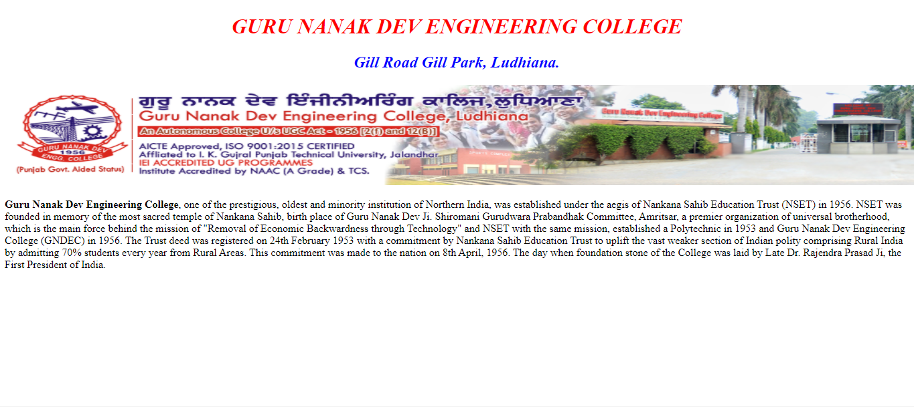

**PRACTICAL NO. 2**

Demonstrate the use of links, lints, and tables in html. You should be able to link separate pages and create named links within a document, using them to build a “table of contents”.

<!DOCTYPE html>

<html lang="en">

  <head>

    <meta charset="UTF-8" />

    <meta http-equiv="X-UA-Compatible" content="IE=edge" />

    <meta name="viewport" content="width=device-width, initial-scale=1.0" />

    <meta name="description" content="Ths Page is basically for Tables">

    <title>Practical 2</title>

    <style>

      table,

      th,

      td {

        border: 2px solid rgb(73, 128, 76);

        border-collapse: separate;

        background-color: rgb(229, 233, 13);

      }

    </style>

  </head>

  <body style="text-align: center" >

    <h1>Practical 2 </h1>

    <h2>Use of Tables, Links and Lists </h2>

    <br />

    <table style="width: 60%; margin-left: auto; margin-right: auto">

      <tr>

        <th>Site Name</th>

        <th>Links</th>

        <th>Link Address</th>

      </tr>

      <tr>

        <tr>

            <td>GNDEC</td>

            <td><a href="https://www.gndec.ac.in/" target="_blank">GNDEC</a></td>

            <td>https://www.gndec.ac.in/</td>

          </tr>

        <td>GNDEC Student portal</td>

        <td><a href="https://guru.gndec.ac.in/" target="_blank">Guru Portal</a></td>

        <td>https://www.guru.gndec.ac.com/</td>

      </tr>

      <tr>

        <td>GNDEC Academics Portal</td>

        <td>

          <a href="https://academics.gndec.ac.in/" target="_blank">Academics Portal</a>

        </td>

        <td>https://www.academics.gndec.ac.com/</td>

      </tr>

    </table>

    <h3 style="text-align: left;">There are mainly 2 types of list: </h3>

    <ol style="text-align: left">

      <strong>Ordered List</strong>

      <li>GNDEC</li>

      <li>Ludhiana</li>

      <li>Punjab</li>

    </ol>

    <ul style="text-align: left">

      <strong>Unordered List</strong>

      <li>GNDEC</li>

      <li>Ludhiana</li>

      <li>Punjab</li>

    </ul>

  </body>

</html>

**OUTPUT**

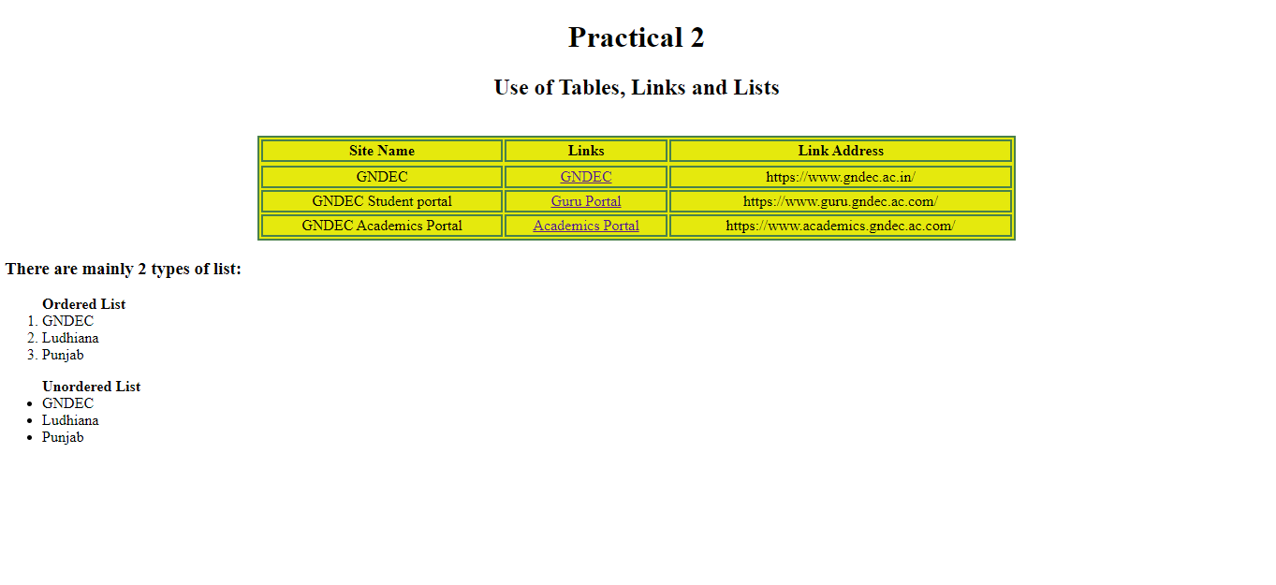

**PRACTICAL NO. 3**

Create a simple forms in HTML and demonstrate the use of various form elements like input box, textarea, submit and radio buttons etc.

<!DOCTYPE html>

<html lang="en">

<head>

    <meta charset="UTF-8">

    <meta http-equiv="X-UA-Compatible" content="IE=edge">

    <meta name="viewport" content="width=device-width, initial-scale=1.0">

    <title>Document</title>

</head>

<body style="background-color: rgb(204,236,255);" >

    <h2 style="color:rgb(002,042,086)"><center>OPD Form</center></h2>

    <form action="2.html">

       <b>OPD No.</b>: <input type="value" name="OPD No." >

<br><div><br>

       <b>Name</b>: <input type="text" name="Name" >

       <b>Date</b>: <input type="Date" name="date" >

<br><div><br>

       <b>Father's Name</b>: <input type="text" name="Father's Name" >

       <b>Contact No.</b>: <input type="value" name="Contact No." >

<br><div><br>

       <b>Age(in years)</b>: <input type="value" name="Age" >

<br><div><br>

       <b>Gender</b>:Male  <input type="radio" name="Gender" >

                     Female  <input type="radio" name="Gender" >

                     Others  <input type="radio" name="Gender" >

<br><div><br>

       <b>Occupation</b>: <input type="text" name="occupation" >

<br><div><br>

       <b>Address : <br>

         <textarea rows = "5" cols = "50" name = "Address">

         </textarea>

<br><div><br>

<button type="submit"> Submit</button>

<button type="reset"> Reset</button>

    </form>

</body>

</html>

**OUTPUT**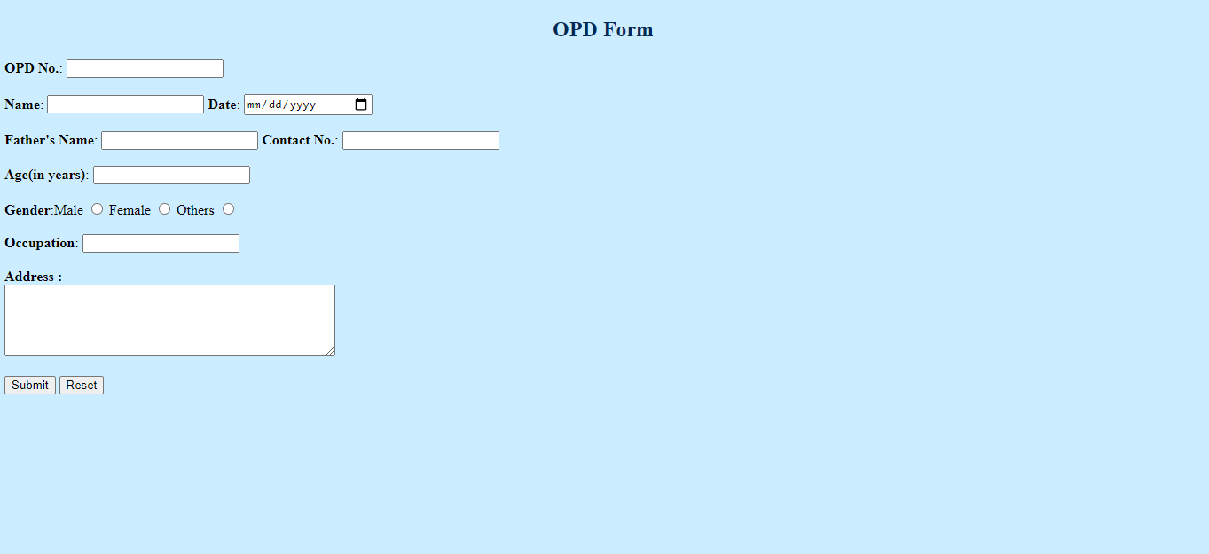

**PRACTICAL NO. 4**

Demonstrate the use of cascading style sheets(CSS) (inline, internal and external) to specify various aspects of style, such as colours and text fonts and sizes, in HTML document.

<!DOCTYPE html>

<html>

<head>

<meta http-equiv="Content-Type" content="text/html; charset=utf-8" />

<style>

body {background-color: lavender;}

h1   { color:rgb(255, 0, 102);

      text-align:center;

      text-transform:capitalize;

      text-decoration:underline;}

h2  {

      color:rgb(0,0,102);

      text-align:center;

      margin-left:10px  }

p    {font-size:16x;

      font-family:Bell MT;

      color: black;}

img  {border:10px           single rgb(7, 7, 7);

      width:4500;

      height:300px;

      margin-left:10px;

      }

      a{

      margin-left:10px;

      }

</style>

</head>

<body>

<h1>WT Practical 4</h1>

<h2> GURU NANAK DEV ENGINEERING COLLEGE</h2>

<p>Guru Nanak Dev Engineering College, one of the prestigious, oldest and minority institution of Northern India, was established under the aegis of Nankana Sahib Education Trust (NSET) in 1956. NSET was founded in memory of the most sacred temple of Nankana Sahib, birth place of Guru Nanak Dev Ji. Shiromani Gurudwara Prabandhak Committee, Amritsar, a premier organization of universal brotherhood, which is the main force behind the mission of "Removal of Economic Backwardness through Technology" and NSET with the same mission, established a Polytechnic in 1953 and Guru Nanak Dev Engineering College (GNDEC) in 1956. The Trust deed was registered on 24th February 1953 with a commitment by Nankana Sahib Education Trust to uplift the vast weaker section of Indian polity comprising Rural India by admitting 70% students every year from Rural Areas. This commitment was made to the nation on 8th April, 1956. The day when foundation stone of the College was laid by Late Dr. Rajendra Prasad Ji, the First President of India.</p>

<center><img src="https://images.shiksha.com/mediadata/images/1489641871php5ZZD7g.png" alt="gne" ></center><br /><br />

<a href="https://images.app.goo.gl/8y6vQs7WpiA3zwie6" target="_blank">More Images & Details</a>

</body>

</html>

**OUTPUT**

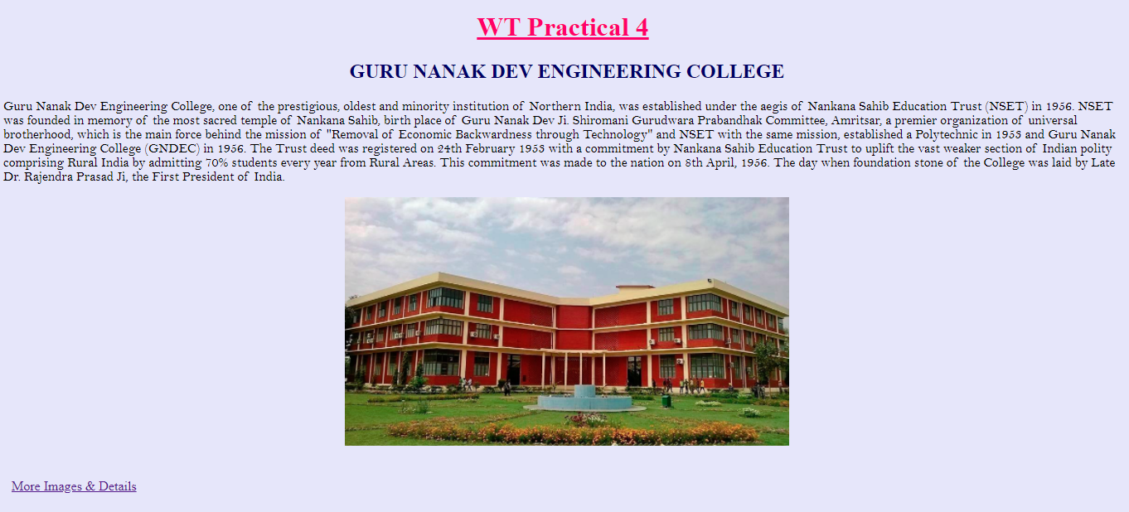

**PRACTICAL NO. 5**

Create of web pages using HTML5 & CSS3.

**HTML**

<!DOCTYPE html>

<html lang="en-us">

<head>

<title>Practical 5</title>

<link rel="stylesheet" href="practical5.css">

</head>

<body>

<div class="hero">

<div class="navbar">

<form action="http://www.google.com">

<button type="submit">Sign up</button>

<button type="submit">Sign in</button>

</form>

</div>

<div class="content">

<b>

<h2>Welcome to</h2>

<h1>Coding Blink</h1>

<form action="https://www.w3schools.com/" target="_blank">

<button type="submit">Start Learning Today</button></form>

</div>

</b>

<div class="side-bar">

<div class="social-links">

<img src="https://i.pinimg.com/736x/ac/57/3b/ac573b439cde3dec8ca1c6739ae7f628.jpg">

<img src="https://encrypted-tbn0.gstatic.com/images?q=tbn:ANd9GcQB-UEqRDXDUJBFl9dgaL7Bz2qMnsFR_E4Rgg&usqp=CAU">

<img src="https://encrypted-tbn0.gstatic.com/images?q=tbn:ANd9GcRBqmHlHR0RrCMDPLbMSemzDzvOJ-gOkTm4lA&usqp=CAU">

</div>

</div>

</div>

</div>

</body>

</html>

**CSS**

*{

    margin: 0;

    padding: 0;

    font-family: sans-serif;

    }

    .hero {

     width: 100%;

     height: 100vh;

     background-image: url(https://www.goodcore.co.uk/blog/wp-content/uploads/2019/08/coding-vs-programming-2.jpg);

     background-size: cover;

    background-position: center;

     position: relative;

     overflow: hidden;

    }

    .logo {

     width: 100px;

     cursor: pointer;

    }

    .navbar{

     width:85%;

     height: 15%;

     margin: auto;

     display: flex;

     align-items: center;

     justify-content: space-between;

    }

    button{

     color: rgb(255, 255, 255);

     padding: 5px 10px;

     background: transparent;

     border: 1px solid rgb(250, 8, 8);

     border-radius: 10px;

     outline:rgb(15, 122, 122);

     cursor: pointer;

    }

    .content{

     color: #fdfeff;

     position: absolute;

     top: 50%;

     left: 5%;

     transform: translateY(-50%);

     z-index: 2;

    }

    h1{

     font-family: Bell MT;

     font-size: 80px;

     margin: 10px 0 30px;

     line-height: 80px;

    }

    .side-bar{

     width: 50px;

     height: 100vh;

     background: linear-gradient(#9c9c9c, #589bda);

     position: absolute;

     right: 0;

     top: 0;

    }

    .social-links, img{

     width: 45px;

     margin: 5px auto;

     cursor: pointer;

    }

    .social-links{

     width: 50px;

     text-align: center;

     position: absolute;

     top: 50%;

     transform: translateY(-50%);

    }

OUTPUT



**PRACTICAL NO. 6**

Demonstrate the use of Bootstrap framework.

<!doctype html>

<html lang="en">

<head>

    <!-- Required meta tags -->

    <meta charset="utf-8">

    <meta name="viewport" content="width=device-width, initial-scale=1, shrink-to-fit=no">

    <!-- Bootstrap CSS -->

    <link rel="stylesheet" href="https://stackpath.bootstrapcdn.com/bootstrap/4.1.3/css/bootstrap.min.css"

        integrity="sha384-MCw98/SFnGE8fJT3GXwEOngsV7Zt27NXFoaoApmYm81iuXoPkFOJwJ8ERdknLPMO" crossorigin="anonymous">

    <title>Practical 6</title>

</head>

<body>

    <nav class="navbar navbar-expand-lg navbar-dark bg-dark">

        <a class="navbar-brand" href="#">WTP</a>

        <button class="navbar-toggler" type="button" data-toggle="collapse" data-target="#navbarSupportedContent"

            aria-controls="navbarSupportedContent" aria-expanded="false" aria-label="Toggle navigation">

            <span class="navbar-toggler-icon"></span>

        </button>

        <div class="collapse navbar-collapse" id="navbarSupportedContent">

            <ul class="navbar-nav mr-auto">

                <li class="nav-item active">

                    <a class="nav-link" href="#">Home <span class="sr-only">(current)</span></a>

                </li>

                <li class="nav-item">

                    <a class="nav-link" href="#">About</a>

                </li>

                <li class="nav-item dropdown">

                    <a class="nav-link dropdown-toggle" href="#" id="navbarDropdown" role="button"

                        data-toggle="dropdown" aria-haspopup="true" aria-expanded="false">

                        Topics

                    </a>

                    <div class="dropdown-menu" aria-labelledby="navbarDropdown">

                        <a class="dropdown-item" href="#">HTML</a>

                        <a class="dropdown-item" href="#">CSS</a>

                        <div class="dropdown-divider">JavaScript</div>

                        <a class="dropdown-item" href="#">Jquery</a>

                        <a class="dropdown-item" href="#">Ajax</a>

                        <div class="dropdown-divider"></div>

                        <a class="dropdown-item" href="#">PHP</a>

                        <a class="dropdown-item" href="#">Bootstrap</a>

                    </div>

                </li>

                <li class="nav-item">

                    <a class="nav-link" href="#">Contact Us</a>

                </li>

            </ul>

            <form class="form-inline my-2 my-lg-0">

                <input class="form-control mr-sm-2" type="search" placeholder="Search" aria-label="Search">

                <button class="btn btn-outline-success my-2 my-sm-0" type="submit">Search</button>

            </form>

        </div>

    </nav>

    <div id="carouselExampleIndicators" class="carousel slide carousel-fade" data-ride="carousel">

        <ol class="carousel-indicators">

            <li data-target="#carouselExampleIndicators" data-slide-to="0" class="active"></li>

            <li data-target="#carouselExampleIndicators" data-slide-to="1"></li>

            <li data-target="#carouselExampleIndicators" data-slide-to="2"></li>

        </ol>

        <div class="carousel-inner">

            <div class="carousel-item active">

                <img class="d-block w-100" src="https://source.unsplash.com/1400x300/?nature,water" alt="First slide">

                <div class="carousel-caption d-none d-md-block">

                    <h2>GEOGRAPHY</h2>

                    <p>Geography is the study of places and the relationships between people and their environments.</p>

                    <button class="btn btn-danger">Register</button>

                    <button class="btn btn-primary">Courses</button>

                    <button class="btn btn-success">Learn More</button>

                </div>

            </div>

            <div class="carousel-item">

                <img class="d-block w-100" src="https://source.unsplash.com/1400x300/?nature,python" alt="Second slide">

                <div class="carousel-caption d-none d-md-block">

                    <h2>GEOGRAPHY</h2>

                    <p>Geography seeks to understand where things are found, why they are there, and how they develop and change over time. </p>

                    <button class="btn btn-danger">Register</button>

                    <button class="btn btn-primary">Courses</button>

                    <button class="btn btn-success">Learn More</button>

                </div>

            </div>

            <div class="carousel-item">

                <img class="d-block w-100" src="https://source.unsplash.com/1400x300/?nature,code" alt="Third slide">

                <div class="carousel-caption d-none d-md-block">

                    <h2>GEOGRAPHY</h2>

                    <p>Geography is a field of science devoted to the study of the lands, features, inhabitants, and phenomena of the Earth and planets</p>

                    <button class="btn btn-danger">Register</button>

                    <button class="btn btn-primary">Courses</button>

                    <button class="btn btn-success">Learn More</button>

                </div>

            </div>

        </div>

        <a class="carousel-control-prev" href="#carouselExampleIndicators" role="button" data-slide="prev">

            <span class="carousel-control-prev-icon" aria-hidden="true"></span>

            <span class="sr-only">Previous</span>

        </a>

        <a class="carousel-control-next" href="#carouselExampleIndicators" role="button" data-slide="next">

            <span class="carousel-control-next-icon" aria-hidden="true"></span>

            <span class="sr-only">Next</span>

        </a>

    </div>

    <div class="container my-4">

        <div class="row mb-2">

            <div class="col-md-6">

                <div class="card flex-md-row mb-4 shadow-sm h-md-250">

                    <div class="card-body d-flex flex-column align-items-start">

                        <strong class="d-inline-block mb-2 text-primary">ENROLL</strong>

                        <p class="card-text mb-auto">Enroll into our courses and learn.</p>

                        <a href="#">Continue</a>

                    </div>

                    <img class="card-img-right flex-auto d-none d-lg-block" data-src="holder.js/200x250?theme=thumb"

                        alt="Thumbnail [200x250]" style="width: 200px; height: 250px;"

                        src="https://source.unsplash.com/500x700/?nature,water" data-holder-rendered="true">

                </div>

            </div>

            <div class="col-md-6">

                <div class="card flex-md-row mb-4 shadow-sm h-md-250">

                    <div class="card-body d-flex flex-column align-items-start">

                        <strong class="d-inline-block mb-2 text-success">Test</strong>

                        <p class="card-text mb-auto">Test your skills with our quizes. </p>

                        <a href="#">Continue</a>

                    </div>

                    <img class="card-img-right flex-auto d-none d-lg-block" data-src="holder.js/200x250?theme=thumb"

                        alt="Thumbnail [200x250]" src="https://source.unsplash.com/500x700/?nature,technology"

                        data-holder-rendered="true" style="width: 200px; height: 250px;">

                </div>

            </div>

        </div>

    </div>

</body>

</html>

**OUTPUT**

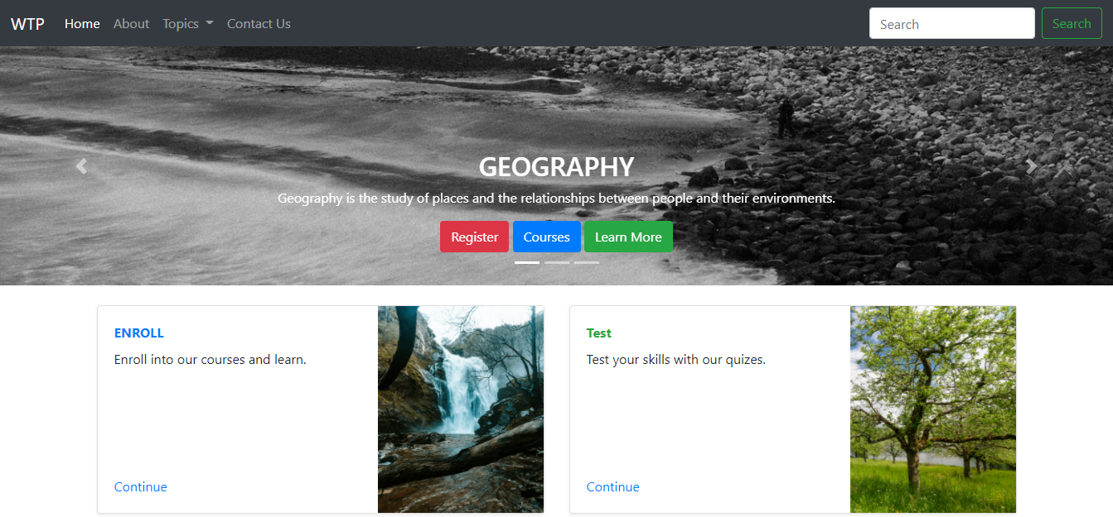

**PRACTICAL NO. 7**

Create a web page using PHP.

<!doctype html>

<html lang="en">

<head>

<meta charset="utf-8">

<meta name="viewport" content="width=device-width, initial-scale=1">

<link href="https://cdn.jsdelivr.net/npm/bootstrap@5.0.0-beta3/dist/css/bootstrap.min.css" rel="stylesheet"

integrity="sha384-eOJMYsd53ii+scO/bJGFsiCZc+5NDVN2yr8+0RDqr0Ql0h+rP48ckxlpbzKgwra6" crossorigin="anonymous">

<title>Practical 7</title>

<body>

<style>.topnav {

overflow: hidden;

background-color: #333;

}

.topnav a {

float: left;

color: #ffffff;

text-align: center;

padding: 14px 16px;

text-decoration: none;

font-size: 17px;

}

.topnav a:hover {

background-color: #86becc;

color: rgb(255, 255, 255);

}

.topnav a.active {

background-color: #86becc;

color: rgb(240, 240, 240);

}

</style>

</head>

<div class="topnav" style="border-radius: 2px;">

<a class="active" href="#HOME">HOME</a>

<a href="#Competition">Competition</a>

<a href="#Contact">Contact</a>

<a href="#About Us">About Us</a>

</div>

<br>

<div class="alert alert-warning alert-dismissible fade show" role="alert">

<strong>Accept Cookies</strong> Accept cookies for better experience

<button type="button" class="btn-close" data-bs-dismiss="alert" arialabe

l="Close"></button>

</div><div class="container" >

<div id="carouselExampleSlidesOnly" class="carousel slide" data-bs-ride="carousel">

<div class="carousel-inner">

<div class="carousel-item active">

<center><img src="https://blog.grinfer.com/wp-content/uploads/2020/02/How-to-Learn-Computer-Programming-Languages.png" width="1000" height="450"></center>

<br> <div>

<center><p style="color: rgb(19, 5, 58)";> Our training workshop will give you the know-how to get started, boost your Employability, Entrepreneurship & Leadership skills and productivity by learning to code, hosting your websites, & designing apps.

    <br><div>

    Ensure you have a stable and great internet connection. Test your internet speed.

    You will need a laptop to take classes and carry out assignments and projects.

    Each session of the training will be intense and you must have a learning and open mindset.

    We are asking for 3 - 4 weeks of your time to give you a life-changing skill.</center>

</div>

</div>

</div>

</div>

</div>

</div><br>

<div class="card" style="width: 125rem; background: linear-gradient(rgb(107, 192, 23

1),rgb(220, 211, 235))" >

<div class="card-body" alignment="center">

<h5 class="card-title">Competition Course </h5>

<p class="cardtext"> Enroll now and start your course </p>

<a href="#" class="btn btn-primary">Get Started</a>

</div>

</div>

</body>

</html

OUTPUT

